Lab 4 Hurricanes, Coriolis effect and the Atmosphere

Land/Sea Air convection
Control click on the link below or cut and paste the link into a web browser.
https://javalab.org/en/sea-and-land-breeze/
Wait for the java simulation to open. It should look like the image below showing how air particles move as they are heated.
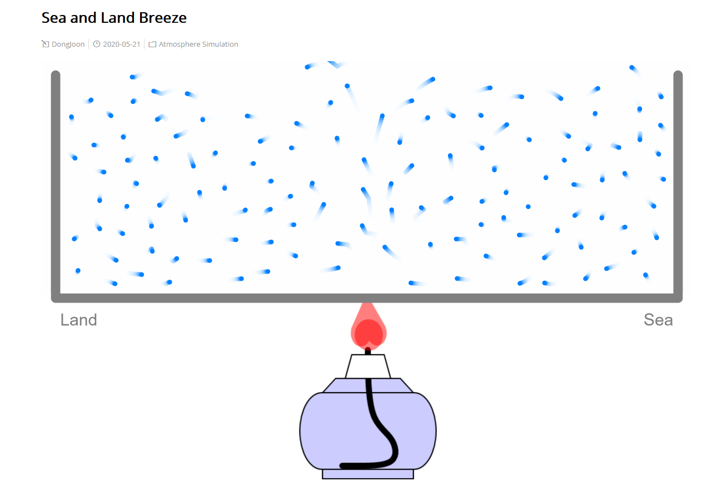
1. Describe how air moves as it heat up and then as it cools down (at the sea and land sides of the box).
Move the lamp at the bottom to the land side of the box by clicking and dragging it. An image will pop up (the lamp is still heating that side).
2. What does this scenario represent?
3. How does the air flow pattern change?
Drag the lamp to the right (sea side) until a new image pops up.
4. What does this scenario represent?
5. How does the air flow pattern change?
6. Describe what you learned about how the direction of the wind along a coast change from day to night.

Coriolis Effect
Control click on the link below or cut and paste the link into a web browser. Wait for the java simulator to open up.
https://javalab.org/en/coriolis_effect_en/
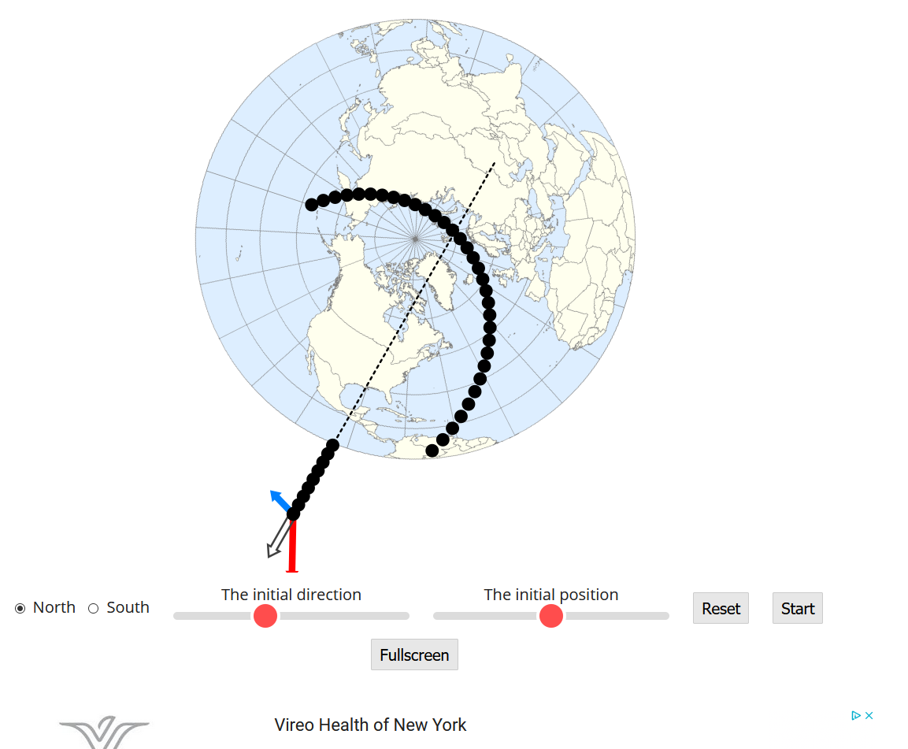

Hit the “Start” button on the far right. When done, hit “Reset”.
7. What happens to the path of the black dot? Why?
Now move the red “Initial direction” and “Initial position”. When you have a position you like, hit “Start” again, and “Reset” when done. Try a few positions.
8. In the northern hemisphere is there a consistent apparent deflection to the Coriolis Effect?
9. Finally, play around with the starting conditions until you can get the black dot to cross over New York. Take a screen shot of the path before hitting reset, and add this picture to your lab report in the data section.
Air currents in the atmosphere
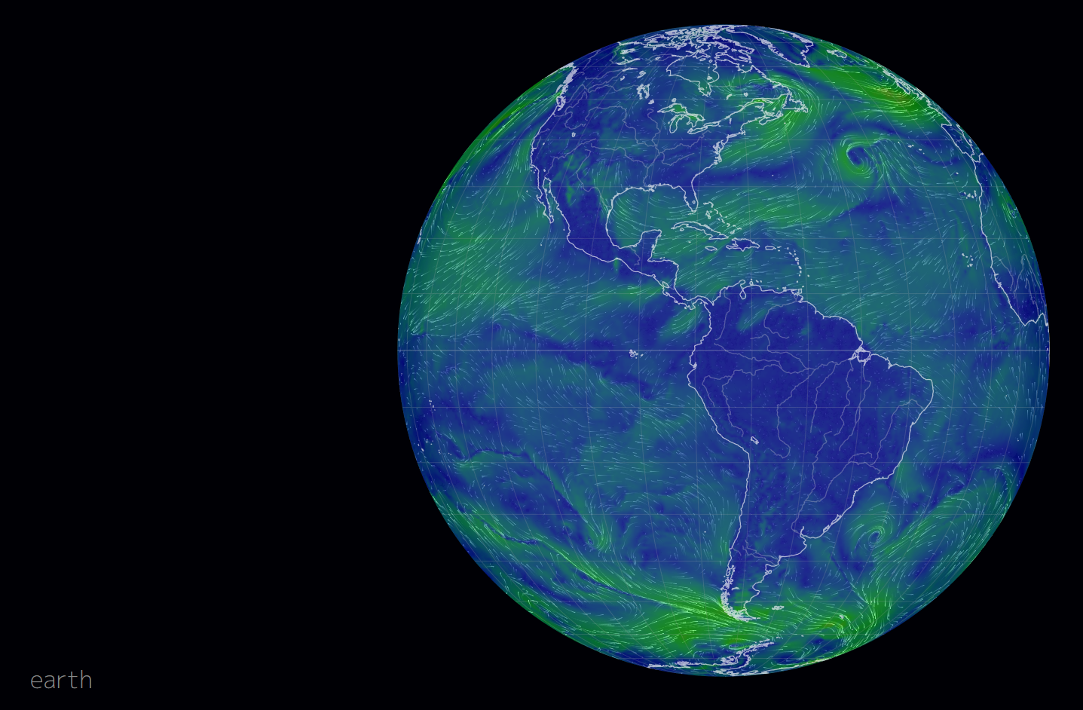
Above is a picture of the current air moments. You will see these motions by clicking on the NullSchool link below.
https://classic.nullschool.net/
You can zoom in and out using the mouse wheel and move global around by click and dragging the mouse. Drag and focus on the Atlantic Ocean.
10. Generally, how do the air currents happening today compare to the ideal, averaged surface wind patterns we learned about that are at the bottom of the 3 atmospheric convection cells? (See picture below for these wind patterns the curved red arrows are the trade winds). You should ignore small hurricanes and storms which might be causing circles to form in the wind patterns.
11. Look for areas where the wind patterns seem to collide (these will look like a light blue line running east to west across the green patterns in the ocean areas). What do these lines correspond to in the picture of wind patterns (Global atmospheric circulations image below)?
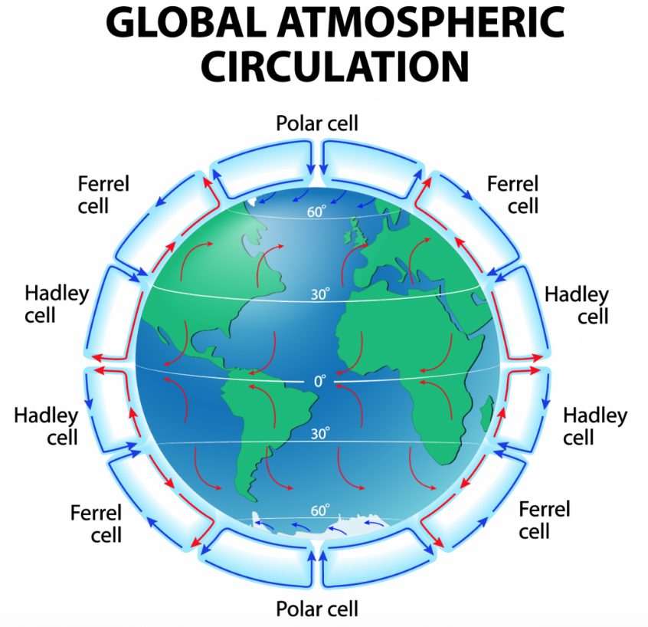

Click on the word “EARTH” in the lower right, and you can access different data.
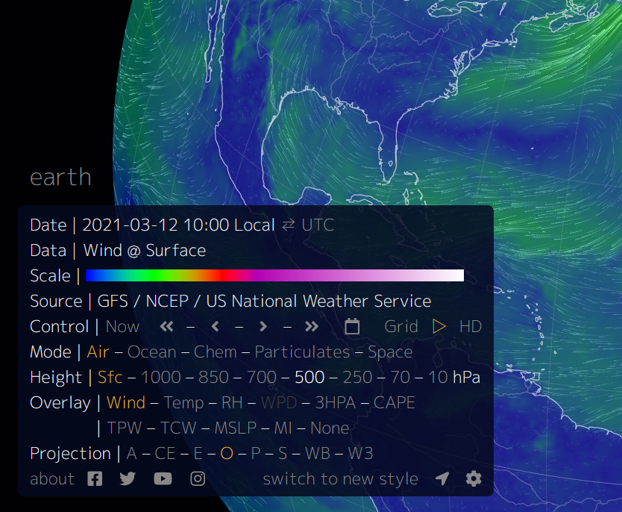
In “Height” you can pick different levels in the atmosphere from Sfc – surface, to the lowest pressure 10hPa which is high up in the atmosphere.
Click through the various levels and study results of each change.
12. At what level do the patterns change directions?
These are at the top of the troposphere and are where the tops of two of the cells shown in the “Global Atmospheric Circulation” picture. Weather forecasters describe this air movement as a Jet Stream and compare it to a river of air flowing 35,000 feet above your head. This air wobbles north and south from day to day, and month to month as the cells adjust to temperatures. It has a huge impact on our daily weather.
13. Move the global around. Does the description of a “river of air” match what you are seeing at 10 hPA?

Hurricanes
Watch the brief (3 min.) video on how hurricanes form. Remember that these same types of storms are given different names – and that in the Pacific Ocean they are called Typhoons.
Hurricane formation video
https://www.youtube.com/watch?v=wPDoIrGUrEc

14. How do hurricanes and typhoons form?
Goto the simulator website.
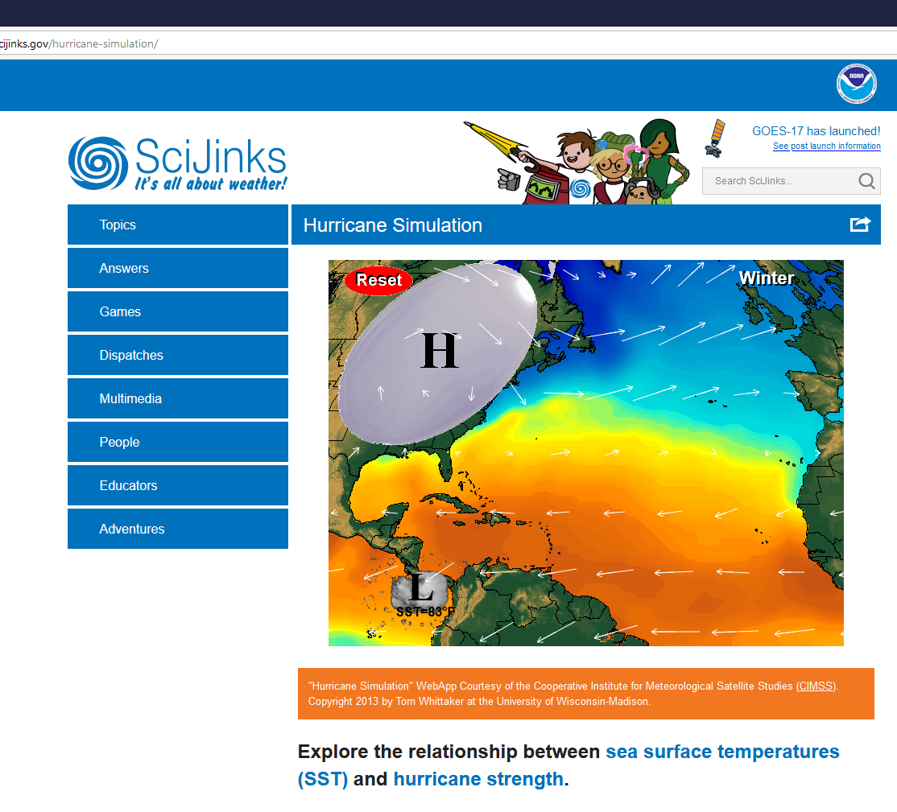
Hurricane Simulator
https://scijinks.gov/hurricane-simulation/

Read the how to use the simulator information right below the window with the simulator (the colored picture with H and L in it).
Drag the H into the far upper left as shown in the picture in this document. Then place the L (low pressure area) in different colored regions and allow the system to move. When the letter “L” changes to a number, then a hurricane has formed.
15. What areas of the simulator (colors) develop into hurricanes? Which areas produce the highest number hurricanes?
16. What do you think the colors of the ocean in the simulator represents?
Click on the word “Winter” in the upper right corner. Cycle through the different seasons and place the “L” area on the different areas.
17. Which season produces the most hurricanes?
18. Why does that season likely produce more hurricanes?
Finally, in Fall season, place the “L” on the right side of the Atlantic near North Africa. Move the “H” to the center of the map so that the upper half off the top of the screen and the lower left edges is a ¼ inch away for the tip of Maine.
19. When a hurricane passes over land (makes landfall) it losses wind speed and the category number drops down. Does the hurricane cross Puerto Rica and Cuba? Where does the hurricane make land fall in the mainland USA?
20. Try varying the “H” and “L” positions slightly. Can you get the hurricane make landfall near New York?
21. What causes the hurricanes to swing North and then West?

